Enitiative Group Website Updates:

1. 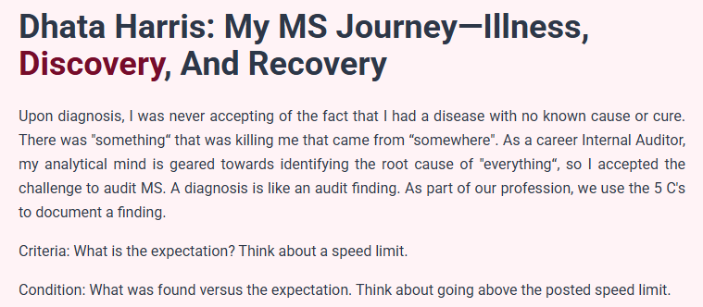Please remove the draft research paper from this page https://www.enitiative.org/ms-journey. There will ultimately be edits, and as I don’t have ability to update this section it will be better to leave it out.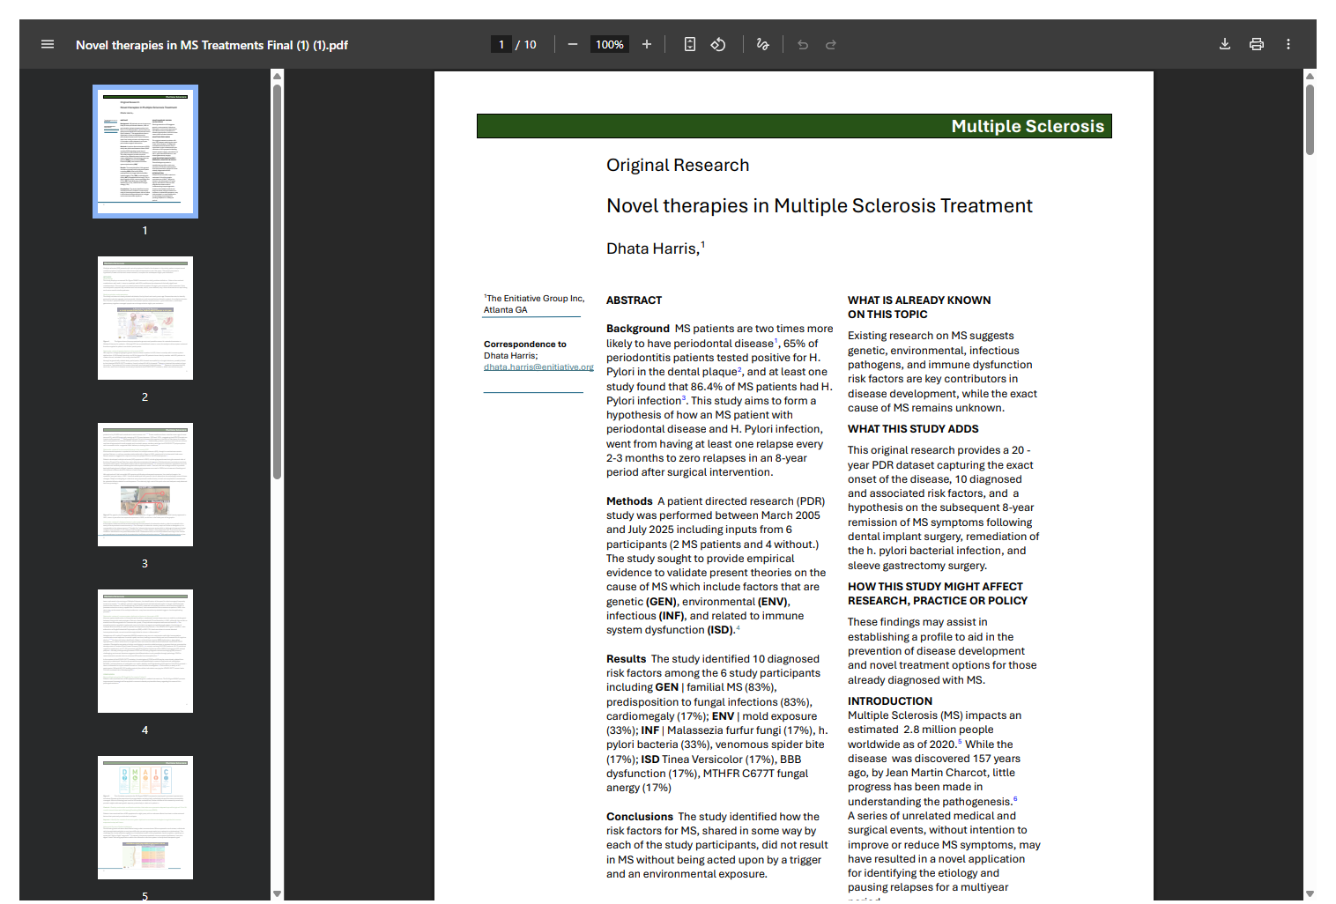
2. Replace this graphic on the ms-journey link with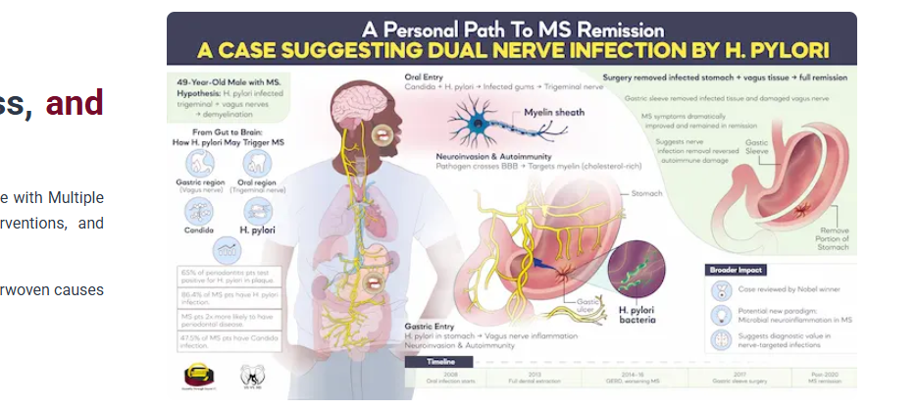 These, the first file is called Graphic 1. The second is Graphic 2. The third is Graphic 3.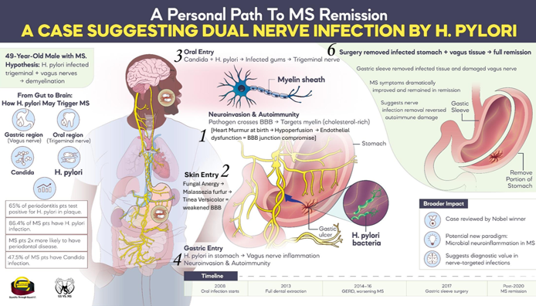

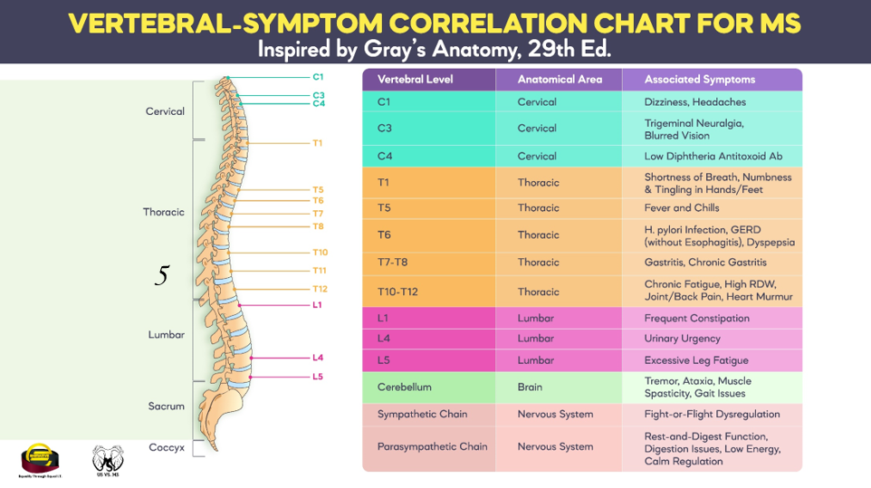

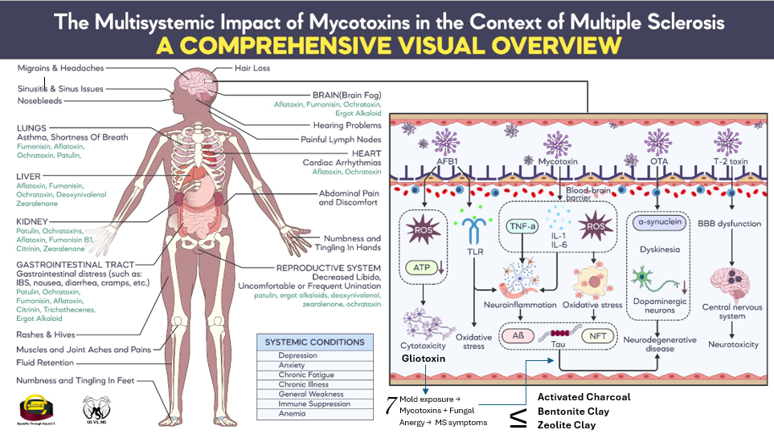

1. 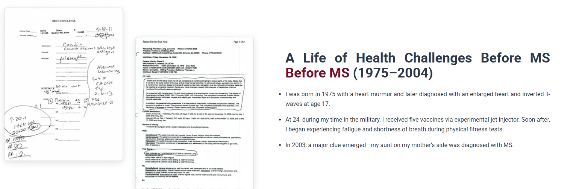Please remove the duplicate phrase “Before MS” before where it says (1975-2004). Replace the two doctor’s visit graphics above with this infographic called Health Challenges 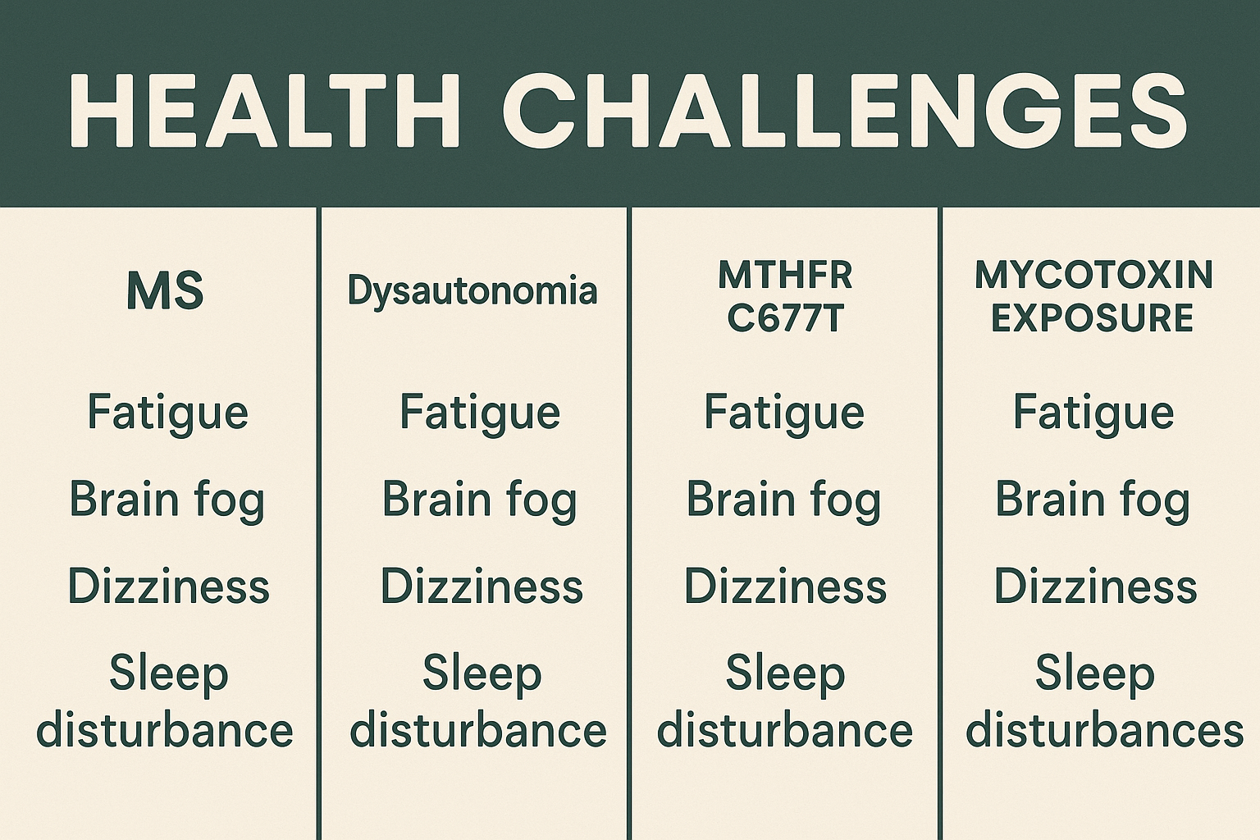
2. 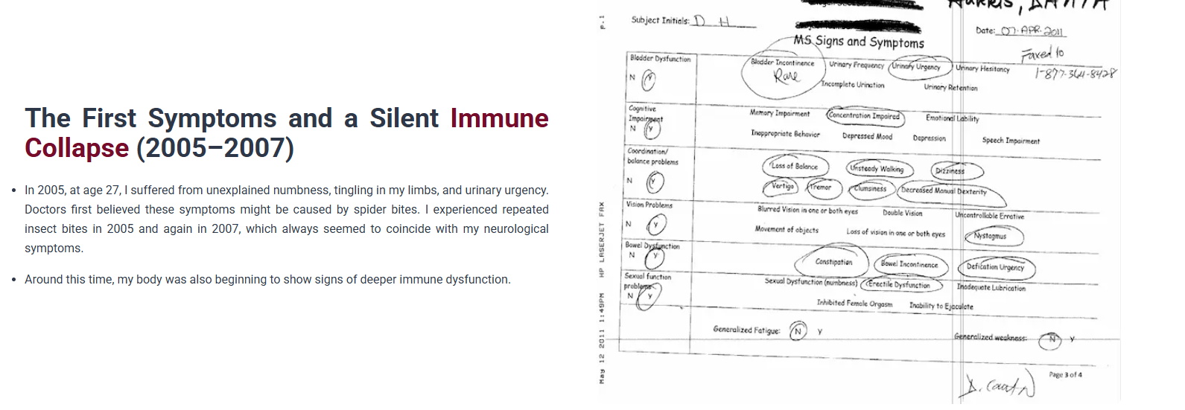Replace the image of the medical record on the right above with this image showing MS symptoms. The file is called MS Symptoms.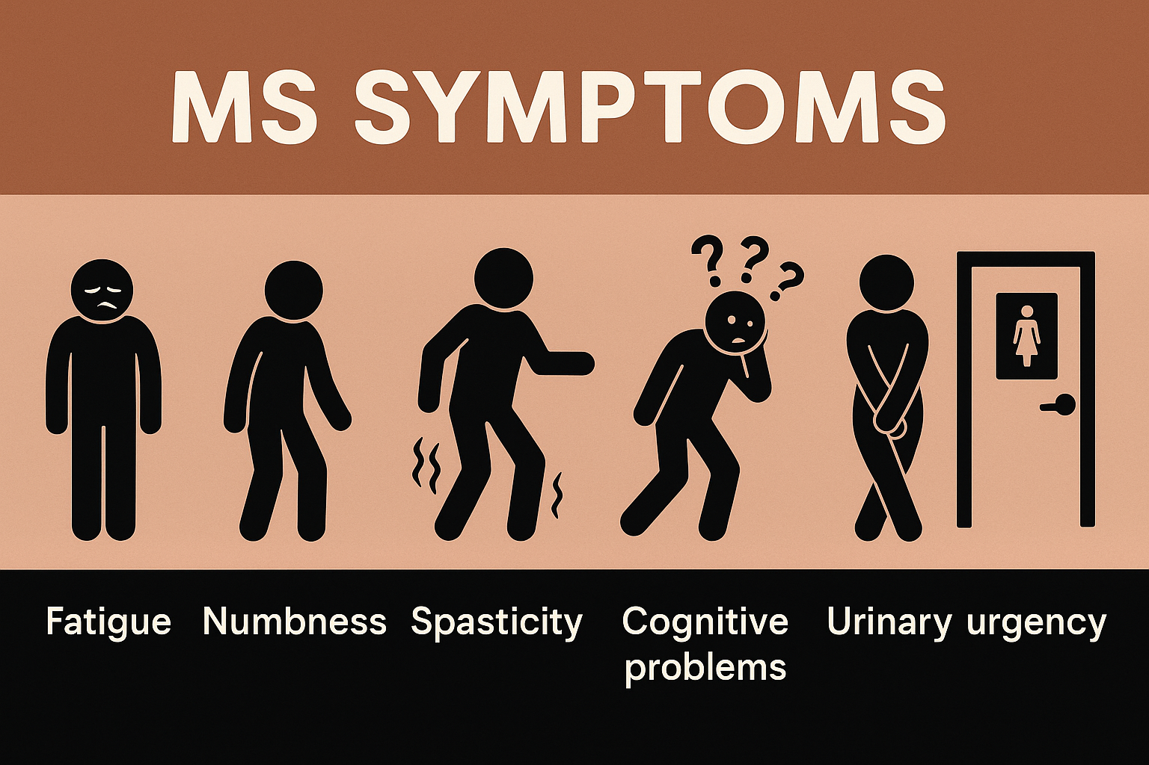
3. 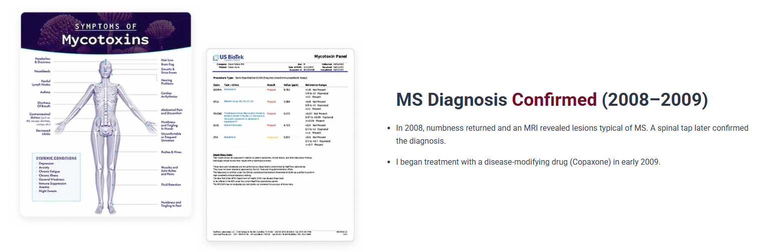Replace the 2 images to the left of the MS Diagnosis Confirmed with this one picture titled Myelin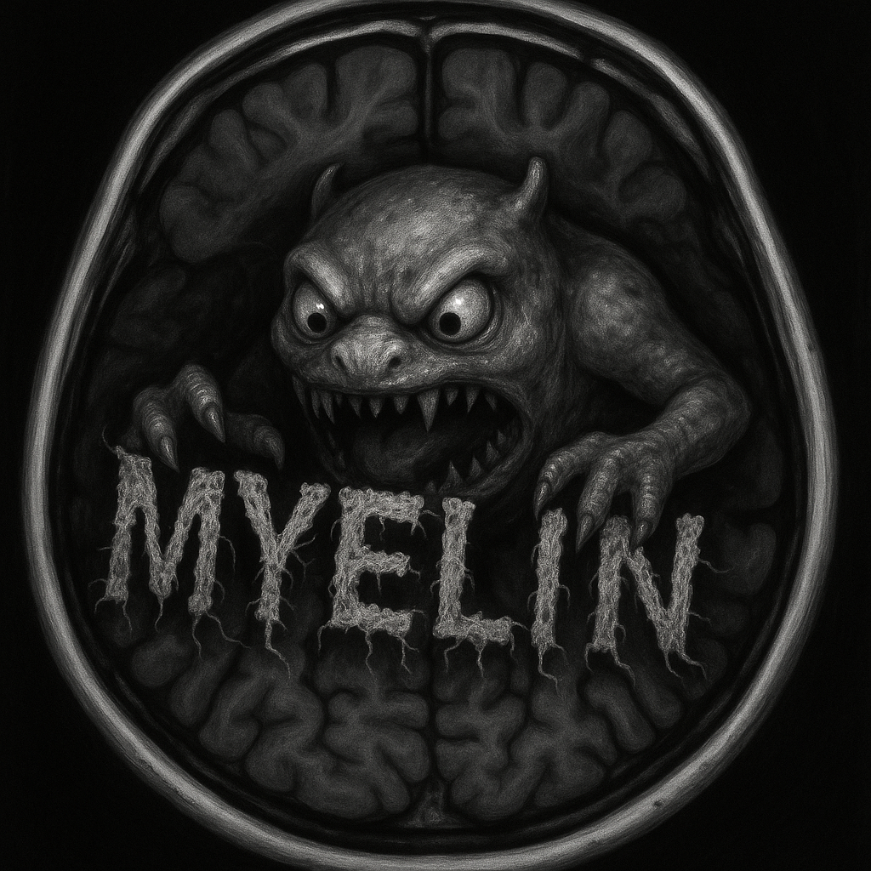
4. Remove the third bullet regarding the anergy panel. 
5. Remove this section. It will no longer be accurate when replacing the images above.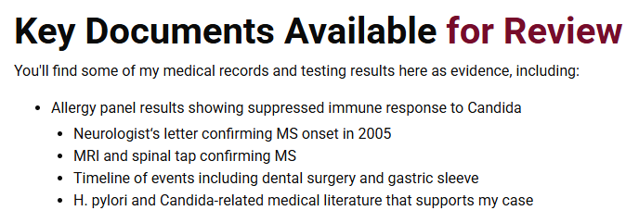
6. Replace the graphic of the mycotoxins 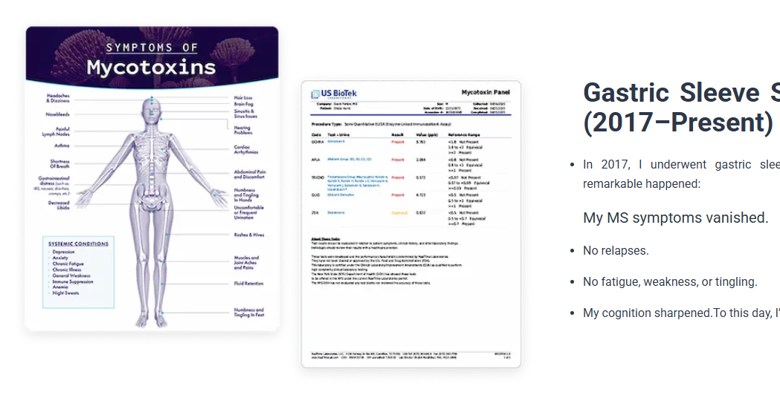With this graphic titled Unwanted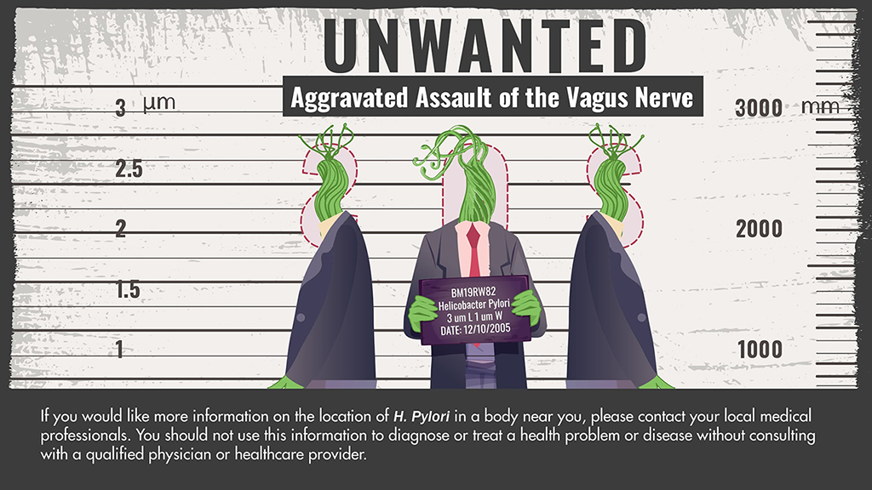
7. This should be a capitalized MS.
8. Also, I got this message from Godaddy about hostinger. Can you please confirm nothing needs to be done on my end? 